CODE AND CIRCUIT

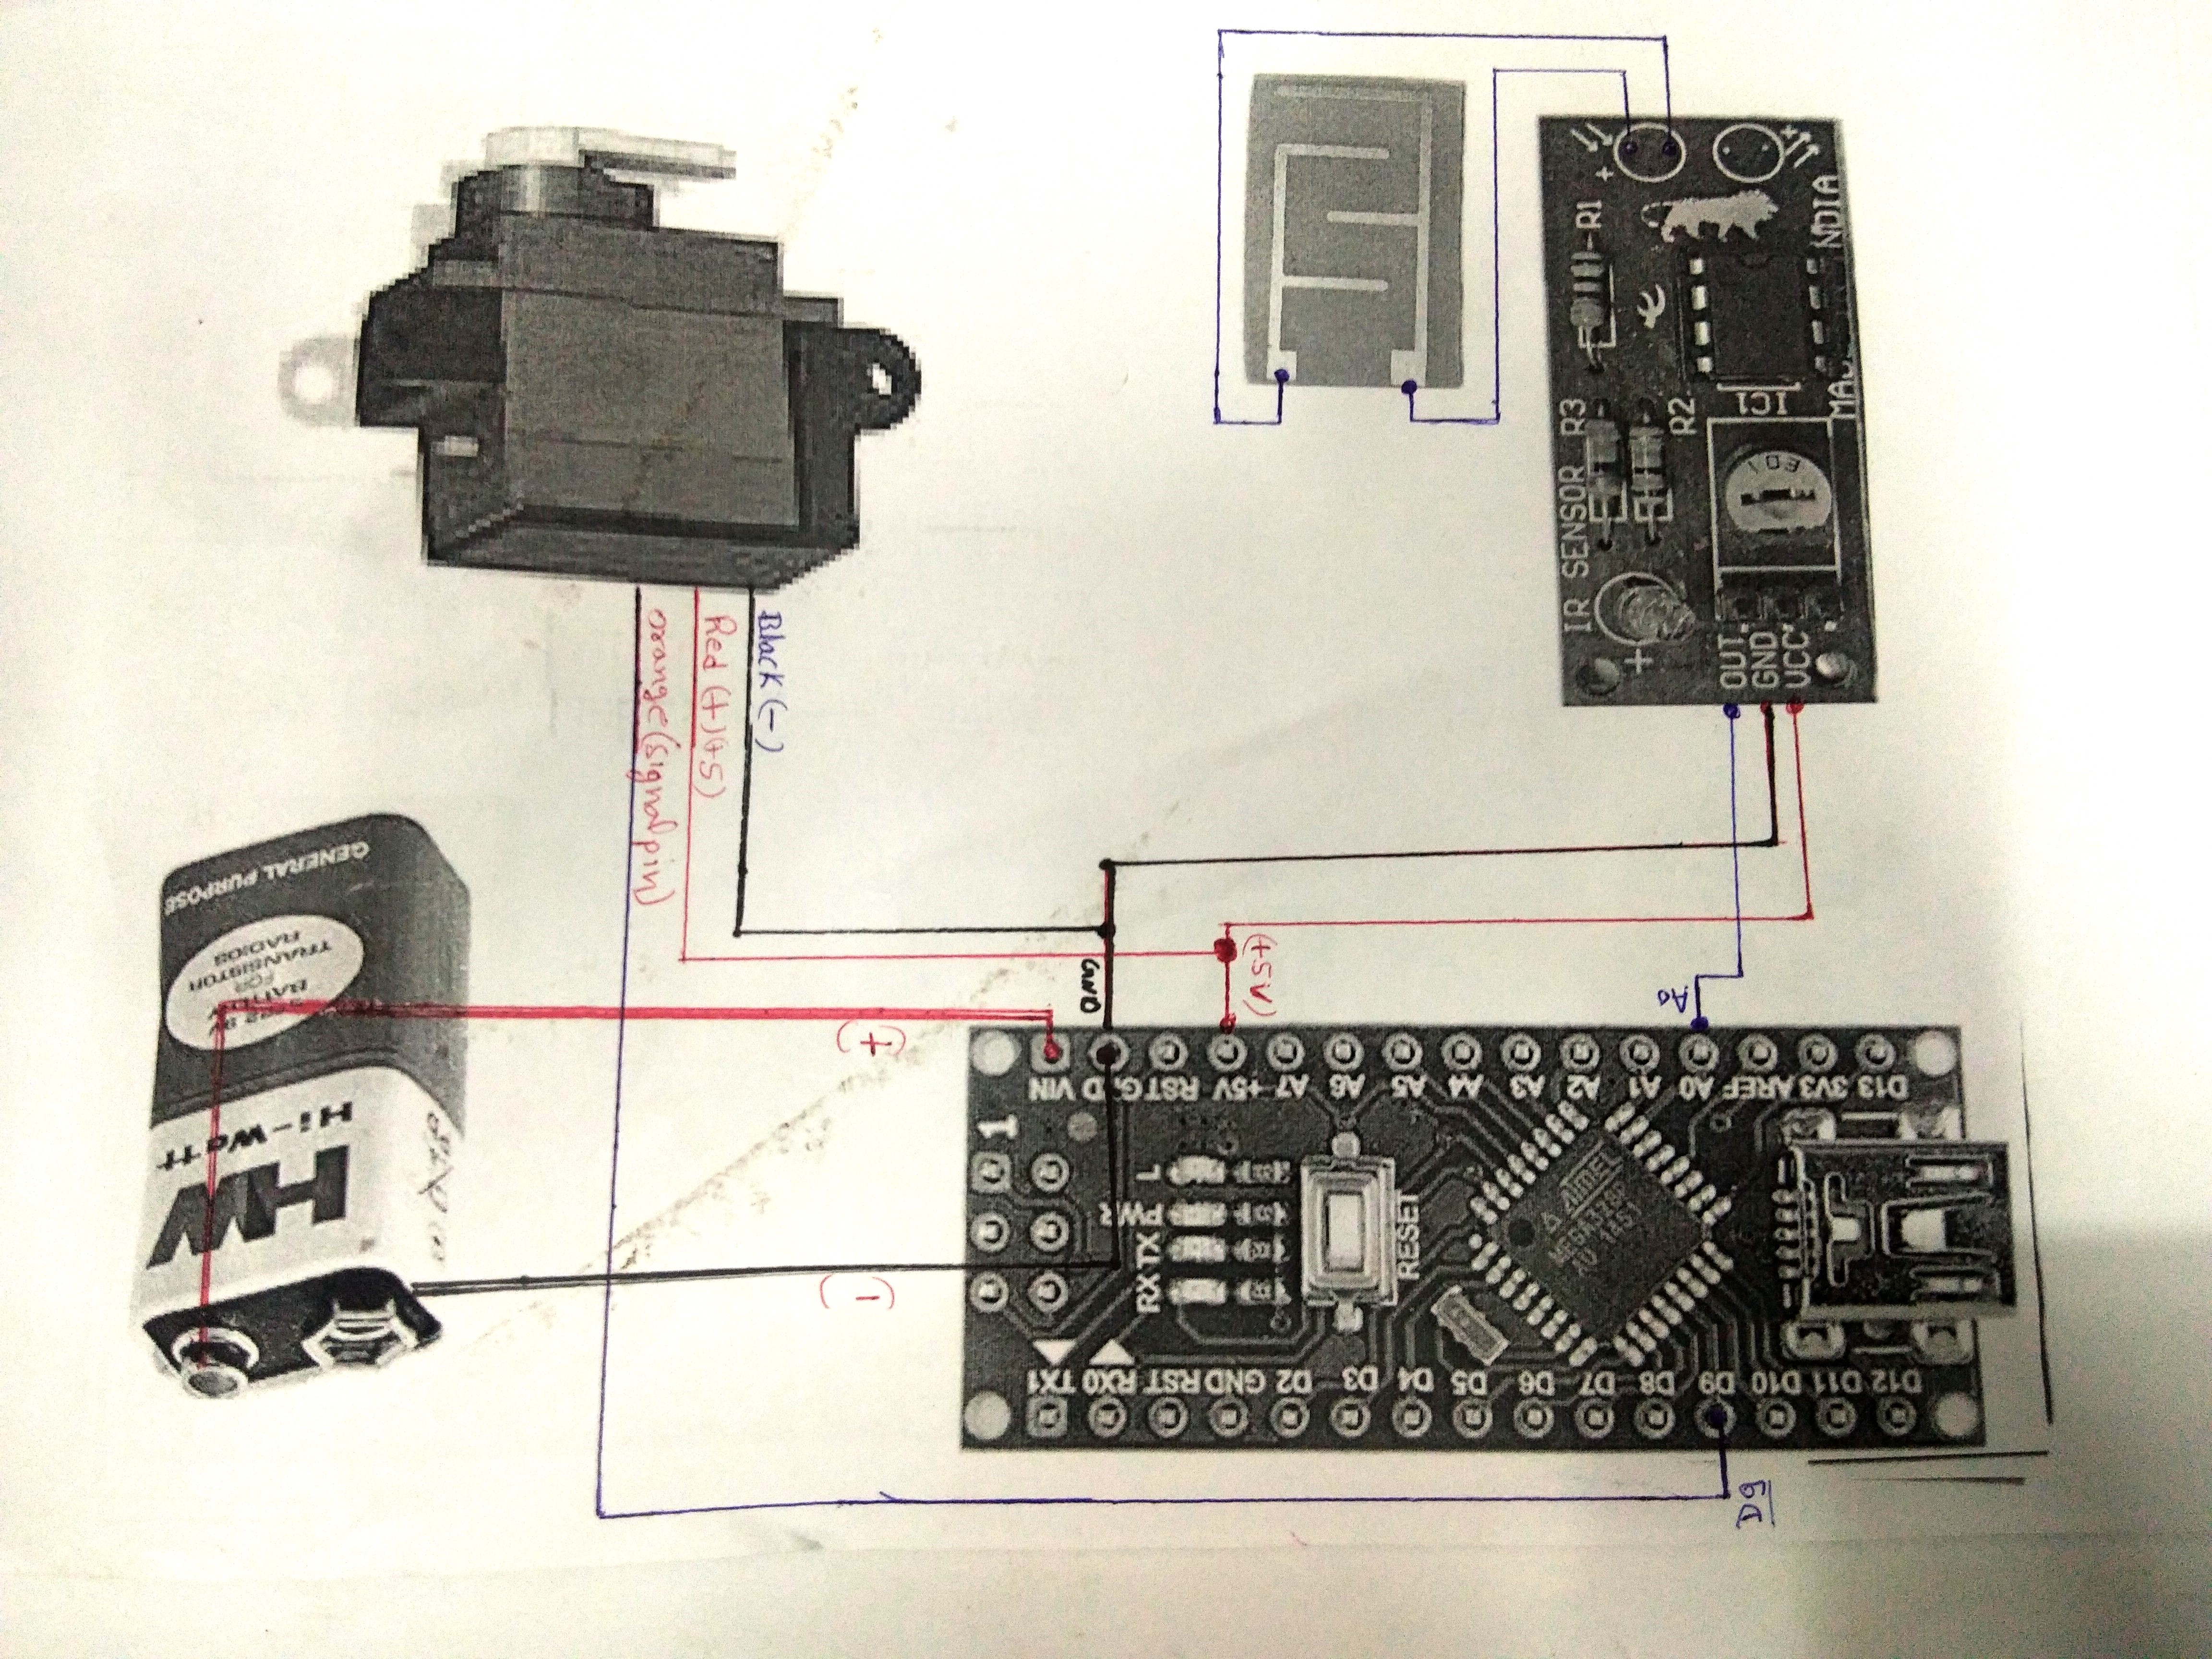

//THIS KIT IS AVALABLE ON srrobotics.in

#include <Servo.h>

Servo myservo;

int pos = 0;

void setup() {

myservo.attach(9);

}

void loop() {

int sensorValue = analogRead(A0);

if (sensorValue > 570)

{

for (pos = 0; pos <= 160; pos += 1) {

// in steps of 1 degree

myservo.write(pos);

delay(7);

}

for (pos = 160; pos >= 0; pos -= 1) {

myservo.write(pos);

delay(7);

}

}

else {

myservo.write(15);

}

}